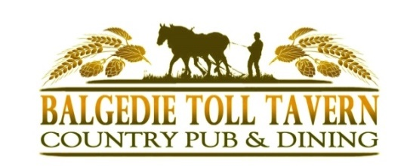
Takeaway Menu July 2021

Starters
SWEET POTATO TACOS 5.50
Sweet potato tacos with mango pico de gallo and vegan coriander mayo. (v) (veg)
PANKO HAGGIS 5.50
Crisp panko breaded haggis served with a spiced apple relish and a wholegrain mustard mayo.
SALMON FISHCAKE 5.75
Hot smoked salmon fishcake with grana padano creamed leeks, hot smoked salmon gribiche and dill oil.
Main Course
BEER BATTERED HADDOCK 11.50
Scrabster landed beer battered or panko coated haddock with chips, tartare sauce and lemon.
BALGEDIE STEAK PIE 11.00
Tender slow braised beef shoulder topped with puff pastry, served with chips or new potatoes and seasonal vegetables.
SCAMPI PRAWN SALAD 11.50
Royal Greenland prawns mixed with a piquant Marie rose sauce with breaded wholetail scampi, tomato, cucumber, frisée lettuce and with a side of chips. (gf* option with no Scampi)
BALGEDIE BURGER 10.00
Chargrilled 6 oz beefburger on a toasted flour bun with our own special burger sauce, pickle, iceberg lettuce, tomato with chips and homemade coleslaw. (gf*) Add Emmenthal cheese/streaky bacon 1.00

CHICKEN PASTA 11.00
Creamy chicken, chestnut mushroom, garlic and smoked bacon penne pasta with Grana Padano cheese and garlic bread.

THAI GREEN CURRY 11.00
Aromatic Thai green mixed vegetable curry with ginger, garlic & coriander basmati rice pilaf, toasted cashew nuts and plantain chips.(v) (veg) (gf)

Desserts
STICKY TOFFEE PUDDING 5.00
Sticky toffee pudding with butterscotch sauce and Chantilly cream. (gf)
COCONUT MILK RICE PUDDING 5.00
Coconut milk rice pudding with poached pears, mango sauce, and a caramelised white chocolate crumb. (veg*) (gf)
CHOCOLATE BROWNIE 5.00
Warm chocolate brownie with a rich dark chocolate sauce and chantilly cream. (gf)

For Our Younger Guests 4.00

4 oz beef or cheeseburger (gf*)
Panko breaded chicken goujons
Battered haddock bites

Add chips or new potatoes, baked beans,
peas or salad.

Allergy Advice
Please let us know before ordering of any food allergies. Our kitchen makes dishes which contain many of the 14 recognised allergens therefore we may not be able to supply an allergen free dish. Please let us know before ordering of any food allergies, so we can let the kitchen know in advance of preparing food, and we will do our utmost to meet your needs.
(v) = vegetarian (veg) = vegan (df) = dairy free
(gf) = made with gluten free ingredients (*) = dish can be amended to be, please ask.

We are currently operating with reduced kitchen staff to allow for social distancing therefore our menu is slightly restricted. All our meals are prepared and cooked freshly to order.

To Order Call 01592 840212

Serving Thursday – Monday from 12 noon – 8pm

